Actual – rafay-monitoring

Yes — that explains it completely.
Your screenshot showing only rafay-system pods means your cluster is effectively running the Minimal Blueprint, not the Rafay Default Blueprint with Monitoring & Alerting.
Rafay's current documentation says the Minimal Blueprint deploys only the Kubernetes Management Operator components, which are exactly what you're seeing in rafay-system. Monitoring is disabled. (Rafay Docs)
So:
rafay-system
├── controller-manager ✓
├── edge-client ✓
├── rafay-connector ✓
└── relay-agent ✓
is normal for Minimal.
There is therefore no:
rafay-infra
└── rafay-prometheus-server
because Monitoring & Alerting isn't enabled.

What I recommend for your cluster
Since your goal is:
Prometheus + Grafana + Loki using Rafay Blueprint/Add-ons
I would create a custom Blueprint based on Rafay default, rather than continuing with Minimal.
Rafay's current documentation says that for VMware vSphere clusters, the supported Default Blueprint is simply default, and that it includes managed services such as Monitoring & Visibility. (Rafay Docs)
The Default Blueprint is also specifically described as carrying core services such as Prometheus and log aggregation, while Minimal contains only the basic management components. (Rafay Docs)

Your target architecture
I would make your Rafay Blueprint:
Rafay SaaS
|
Custom Blueprint
|
Base: default
|
+------------+-------------+
| |
v v
Monitoring & Alerting Your Add-ons
| |
| +--------+--------+
| | | |
v v v v
Prometheus Grafana Loki Alloy
| | | |
+-----------------+--------+--------+
|
Students
With storage:
Grafana PVC ─────┐
|
Loki PVC ────────┼──> vsphere-csi
| |
└────────> StorageClass
|
v
vSphere
DS-186

Step 1 — Create the Blueprint
In Rafay:
Project → Infrastructure → Blueprints
Click:
New Blueprint
Choose:
Type:
Custom Blueprint

Base Blueprint:
default
For example:
Name:
eks-anywhere-observability
Rafay explicitly supports using a Default Blueprint as the base for a custom Blueprint and then adding your own software add-ons. (Rafay Docs)

Step 2 — Enable Monitoring & Alerting
Inside the Blueprint version, under:
Managed System Add-Ons
enable:
Monitoring & Alerting
Rafay's managed Monitoring & Alerting add-on includes:
Prometheus
Alertmanager
Kube State Metrics
Metrics Server
Prometheus Adapter
Node Exporter
and is supported across Kubernetes distributions. (Rafay Docs)
For your EKS Anywhere cluster, I would initially leave the default Monitoring & Alerting configuration unchanged.

Step 3 — Do NOT enable Managed Storage
You already have:
vSphere CSI
+
vsphere-csi StorageClass
and you tested it successfully.
Therefore:
Managed Storage = OFF
Rafay's Managed Storage is Rook-Ceph for upstream Kubernetes; you don't need it for your vSphere CSI architecture. (Rafay Docs)
Your storage architecture remains:
PVC
↓
vsphere-csi
↓
vSphere CSI
↓
DS-186

Step 4 — What happens when you publish this Blueprint
Rafay should create:
rafay-infra
and you'll start seeing components similar to:
rafay-prometheus-server
rafay-prometheus-alertmanager
rafay-prometheus-kube-state-metrics
rafay-prometheus-node-exporter
rafay-prometheus-adapter
rafay-metrics-server
Rafay's documentation shows these components being deployed into rafay-infra by the Managed Monitoring add-on. (Rafay Docs)
Then:
kubectl get pods -n rafay-infra
should return the monitoring stack.

We have to manually expose the prometheus
kubectl patch svc rafay-prometheus-server -n rafay-infra -p '{"spec":{"type":"LoadBalancer"}}'

Step 5 — Then add Grafana
Now create/add your Grafana Add-On to the same custom Blueprint.
Grafana will use Rafay's Prometheus as its datasource.
Rafay documents the managed Prometheus service endpoint as:
http://rafay-prometheus-server.rafay-infra.svc.cluster.local:9090
for connecting a Grafana deployment to the managed Prometheus instance. (Rafay Docs)
So your architecture becomes:
rafay-infra
|
Prometheus
|
|
v
Grafana
Grafana doesn't need its own Prometheus.

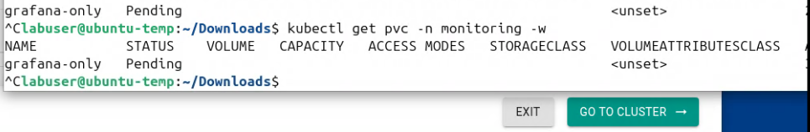
Again issue

We will make the storageclass default

kubectl patch storageclass vsphere-csi \
-p '{"metadata":{"annotations":{"storageclass.kubernetes.io/is-default-class":"true"}}}'

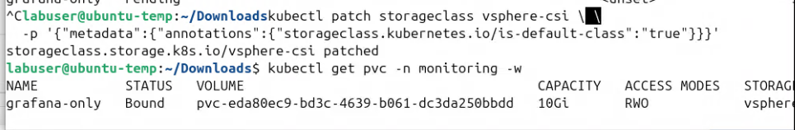
.
its resolved now.

Also the below values.yaml – might work , override in the addon of the grafana

image:
registry: docker.io
repository: bitnamilegacy/grafana
tag: 12.1.1-debian-12-r1

persistence:
enabled: true
type: pvc
storageClassName: vsphere-csi
accessModes:
- ReadWriteOnce
size: 10Gi

we have to manually expose the grafana

kubectl patch svc grafana-only -n monitoring -p '{"spec":{"type":"LoadBalancer"}}'

THE ABOVE IS STILL HAVING ISSUES
We will add the custom helm chart which is latest

Add-On type: Helm 3

Repository:
https://grafana-community.github.io/helm-charts
Chart:
grafana
Version:
12.8.0

task1 – Create repository
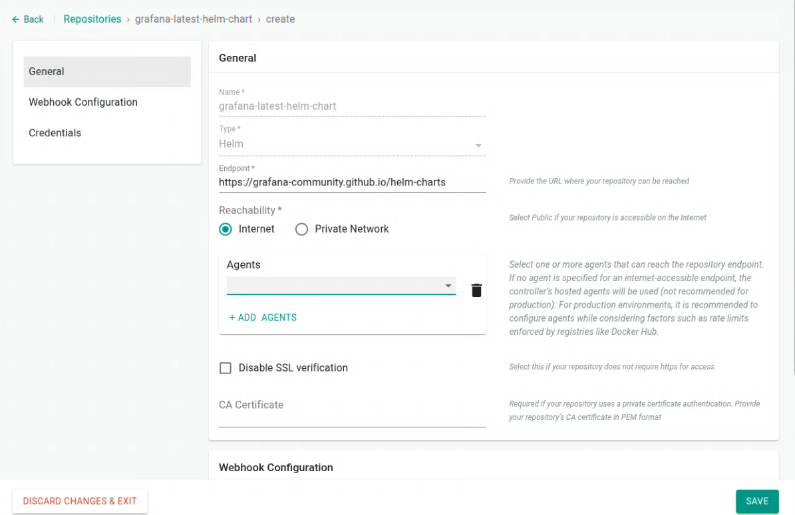

task2 – create new custom add-on

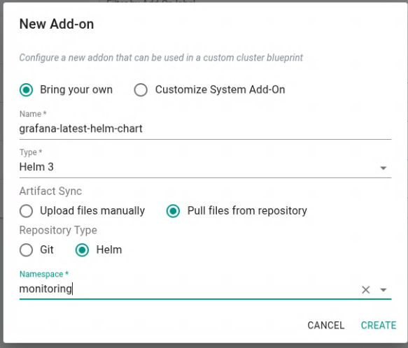
.

replicas: 1

image:
repository: grafana/grafana
tag: "13.1.1"
pullPolicy: IfNotPresent

service:
enabled: true
type: LoadBalancer
port: 3000
targetPort: 3000

persistence:
enabled: true
type: pvc
storageClassName: vsphere-csi
accessModes:
- ReadWriteOnce
size: 10Gi

adminUser: admin

datasources:
datasources.yaml:
apiVersion: 1
datasources:

- name: Prometheus
type: prometheus
access: proxy
url: http://rafay-prometheus-server.monitoring.svc.cluster.local:9090
isDefault: true

- name: Loki
type: loki
access: proxy
url: http://loki-gateway.monitoring.svc.cluster.local

we will use the pre-installed prometheus with rafay

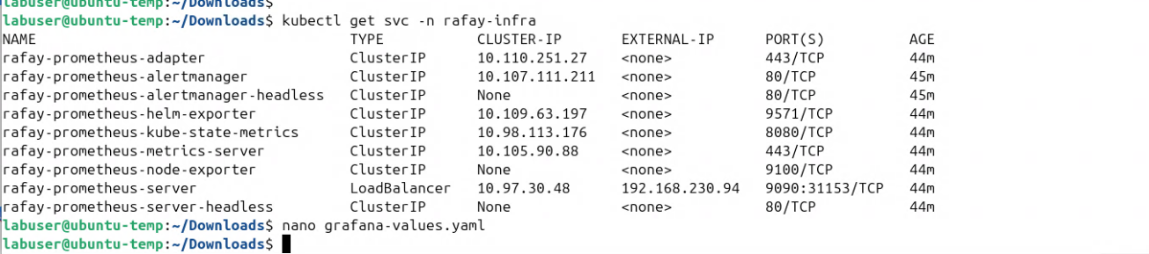
.
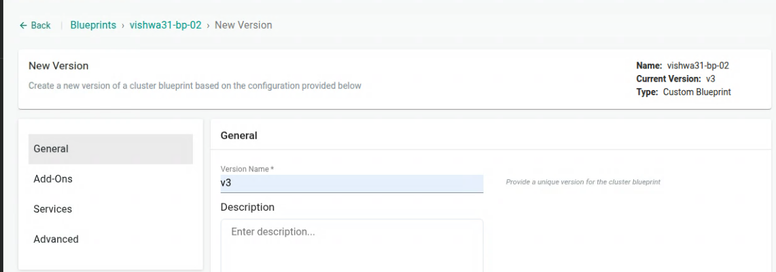
.

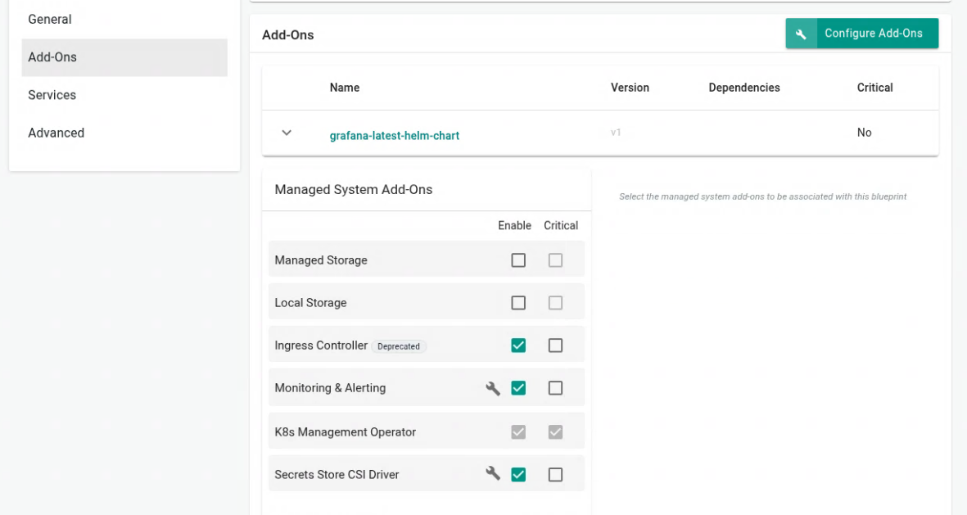

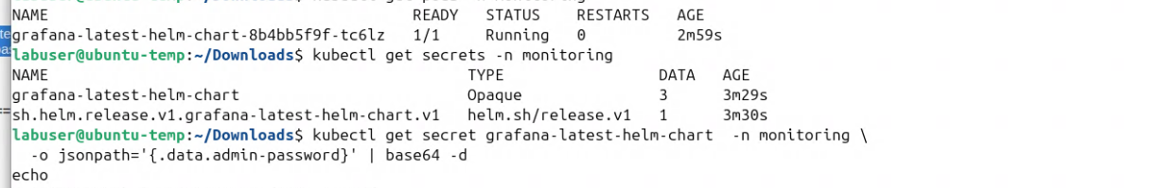

kubectl get secret grafana-latest-helm-chart -n monitoring -o jsonpath='{.data.admin-password}' | base64 -d
echo

Step 6 — Then add Loki
I recommend removing your current grafana-loki Add-On from the Blueprint for now.
Why?
Because we already know that the current Add-On is creating:
ingester
querier
compactor
distributor
query-frontend
gateway
memcached
and its PVCs don't specify your vsphere-csi StorageClass.
For your student lab, I'd use a separate Loki Add-On and explicitly configure persistence.
Then:
Alloy
|
| Kubernetes logs
v
Loki
|
| PVC
v
vsphere-csi

Your final Blueprint
I would make it:
eks-anywhere-observability
│
├── BASE
│ └── default
│
├── MANAGED ADD-ONS
│ │
│ └── Monitoring & Alerting
│ ├── Prometheus
│ ├── Alertmanager
│ ├── Kube State Metrics
│ ├── Node Exporter
│ └── Metrics Server
│
└── CUSTOM ADD-ONS
│
├── Grafana
│ └── PVC → vsphere-csi
│
├── Loki
│ └── PVC → vsphere-csi
│
└── Grafana Alloy
└── logs → Loki
This is much cleaner than trying to make one grafana-loki add-on provide everything.

One important distinction for your students
You can now teach them that Rafay itself has a monitoring stack:
Rafay Managed Monitoring
|
v
Prometheus
|
v
Rafay Cluster Dashboards
while the application observability stack is:
Application
|
+---- metrics ----> Prometheus
|
+---- logs -------> Alloy → Loki
|
v
Grafana
This is actually an excellent Rafay lab because students see the difference between platform monitoring provided by Rafay and application observability that they deploy themselves.
And most importantly, your current rafay-system output is not an error. It is exactly what Rafay documents for a Minimal Blueprint. (Rafay Docs)

I would do this next
Don't change Grafana/Loki again yet.
First create:
Custom Blueprint → Base default → Enable Monitoring & Alerting
Apply it to your existing EKS Anywhere cluster.
Then run:
kubectl get ns
and:
kubectl get pods -n rafay-infra
Once rafay-infra appears with Prometheus, then we'll configure the Grafana Add-On to use that Prometheus, and separately configure Loki with your working vsphere-csi.

